*Quiz Night*

***Friday 21st March 2025***

***The Barn, Foxhall Rd, Didcot,*** 7 for 7.30 start



£8 per person,

up to 8 in a team

All proceeds to:

MS Therapy Centre

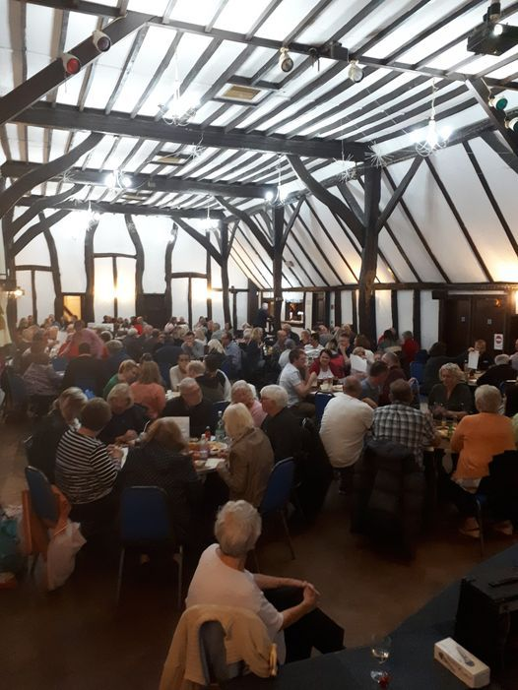

For team application form contact Sue :

[info@omstc.org.uk](mailto:info@omstc.org.uk)

or tel: 01235 832023.

