Friday 12th October 2018
The Barn (Didcot Conservative Club)
7 for 7.30 start – 10.30pm
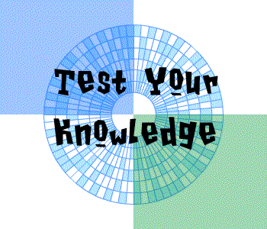
£7 per person
up to 8 in a team

All proceeds to
the MS Therapy Centre

To enter a team contact Sue :
ms.therapy@btconnect.com
or phone: 01235 832023.

