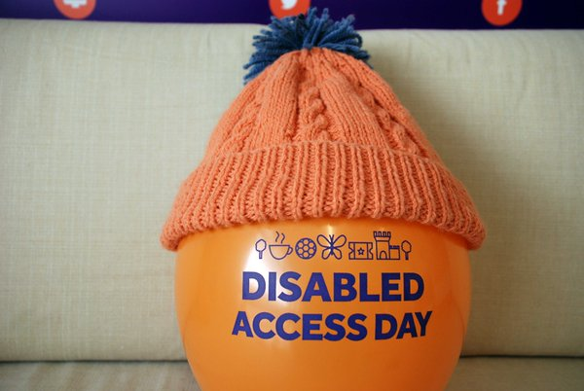

SOLL (VALE) is a charitable company limited by guarantee, registered in England and Wales. Registered no: 5184368.

VAT no: 781501146. Registered office: 17 Croft Drive,

***Leisure***



[](https://www.disabledaccessday.com/)

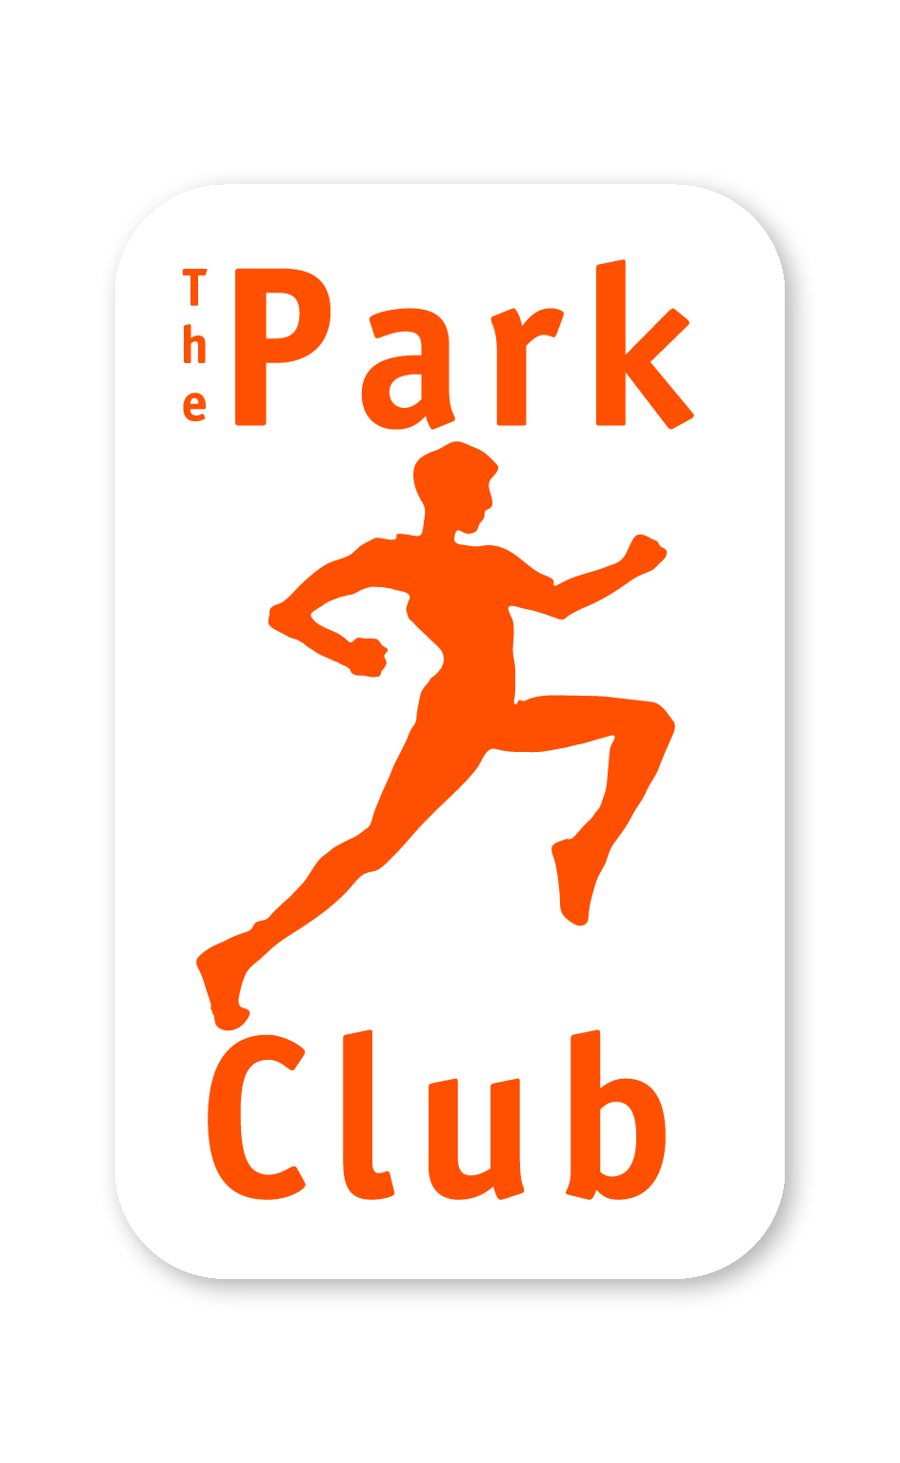10th - 12th March 201710th - 12th March 2017

**Friday 9th – Sunday 11th March**

**We don’t shout enough about the existing activities we offer as a company here at**

**Soll Leisure, Milton Park and Willowbrook Leisure Centre.**

**Disability Access Weekend is an open weekend for individuals with any form of disability to trial the facilities and sessions that we have to offer.**

**Booking is required for all sessions by calling direct on the numbers below or by e-mailing** [**info@soll-leisure.co.uk**](mailto:info@soll-leisure.co.uk)**.**

|  |  |  |  |
| --- | --- | --- | --- |
| **Friday 9th march** | | **Saturday 10th March** | **Sunday 11th March** |
|
| **Park Club Milton – 01235 206777** | | | |
| Swimming 10-11am | |  |  |
|  | |  | Gym Session 11-12noon |
|  |  | Gym Session 1.30-2.30pm | *Karate 12-2pm |
|  | | Swimming 2-3pm | Swimming 2-3pm |
| **Willowbrook Leisure Centre – 01235 812058** | | | |
|  | |  | Obstacle course 9-30-11am |
|  | | *Karate 10-11am  (Wheelchair Accessible) |

**Swimming** – Improve fitness and learn new strokes in this instructor (level 2 ASA) led session (Friday only). Saturday & Sunday 2-3pm Open to all adults (16+) with a disability.

**Gym Session** – Open gym session for adults (16+) with a disability, supervised by a Personal Trainer providing support to improve fitness levels.

**\*Karate** – Run by The Disability Karate Federation for adults with learning disabilities. Donation to participate in the session is welcomed.

**Obstacle Course** – Inflatable obstacle course for adults with learning disabilities

Milton Park, Abingdon, OX14 4RP Tel: 01235 861289