I am raising money to purchase a Defibrillator for the centre.
Please sponsor me on the form below, or at http://uk.virginmoneygiving.com/SueDoran
I am running the Royal Berks 10k on 17 May 2015
Many thanks, Sue
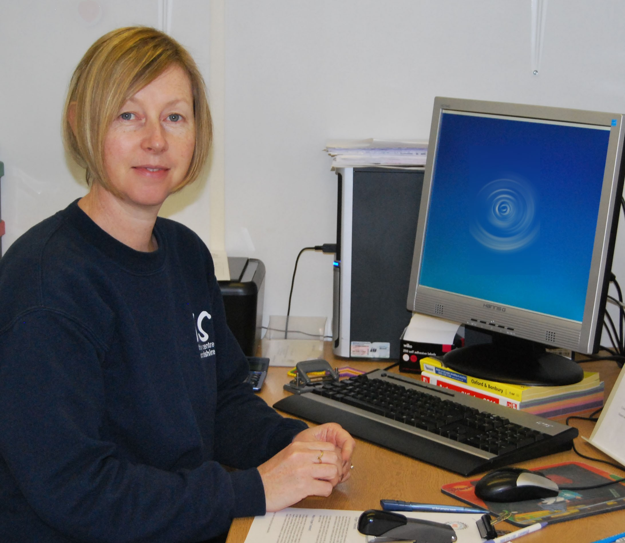
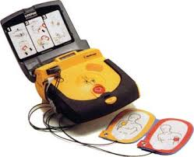

Please sponsor generously! If you are a UK taxpayer*, the Charity can reclaim 25% tax from the Inland Revenue at no extra cost to you, making your donation worth much more. To do this, please write your full name, HOME address and tick in the ‘reclaim tax’ box. It’s as simple as that! Many, many thanks.

*NOTE: you must pay Income or Capital Gains Tax at least equal to the amount of tax we reclaim on your gift.

Date | FULL Name & Home Address, including POSTCODE | Amount | Please reclaim the tax on my gift | Tick when paid

